Gettysburg Address
Judgment Samples of Size 5

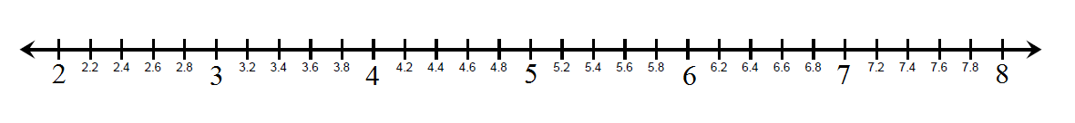
Average Number of Words

Random Samples of Size 5

Average Number of Words

