**School Lunch**

(A sampling activity)

At Lincoln Middle School, students may purchase a hot lunch or bring a lunch from home. The principal of Lincoln Middle School claims that more than 50% of the students tend to buy a school lunch. Marie, who brings her lunch each day, is wondering if this is true. She decides to take a simple random sample of 40 students from their school and finds that 18 of the 40 students said they buy a school lunch. Does this provide evidence that the principal’s claim is incorrect?

* What is the population? __________________________________________________

______________________________________________________________________

* What is the population characteristic of interest? ______________________________

_____________________________________________________________________

* What is the sample? ____________________________________________________

_____________________________________________________________________

* What proportion of the students in the sample said they buy lunch at school? ______

Let’s investigate this using a simulation. In a simulation, we assume that the principal’s claim is true. Suppose that 50% of students buy a school lunch. If we take random samples from the population of all Lincoln Middle School students, we expect that the percentage of students buying lunch in each of these samples, while close to 50%, will vary. Some samples should have more than 50% and some should have less than 50%. Will 18/40 be one of the values that we are likely to get if at least 50% of students bring their lunch?

**The Simulation**

1. Place 5 red chips and 5 white chips in a paper sack. The red chips will represent students who buy their lunch, and the white chips will represent students who bring their lunch.

* What proportion of the chips is red? ________.

This is our population proportion and corresponds to the proportion of Lincoln Middle School students that the principal claims buys their lunch.

1. Shake the bag, then reach in without looking, and pull out a chip. Place a tally mark in the table on the next page in the row that corresponds to this color of the chip.
2. Return the chip to the bag, shake the bag to mix, and pull out another chip. Returning a chip to the bag before sampling again is called sampling with replacement. Note that by returning the chip to the bag each time, the probability of drawing a red remains the same.
3. Repeat this process until you have drawn chips 40 times. These 40 draws make up your simulated sample.

Your Simulated Sample

|  |  |  |
| --- | --- | --- |
| Color | Tally | Proportion |
| Red |  |  |
| White |  |  |

1. The bag of chips represents the population of all Lincoln Middle School students, with red chips being the students who buy their lunch and white being the students who bring their lunch. Your table represents your simulated sample from the population.

* What proportion of your sample “buys lunch at school?” __________

1. Plot your sample proportion of students who “buy lunch at school?” on the class dot plot.
2. Record a copy of the class dot plot below.

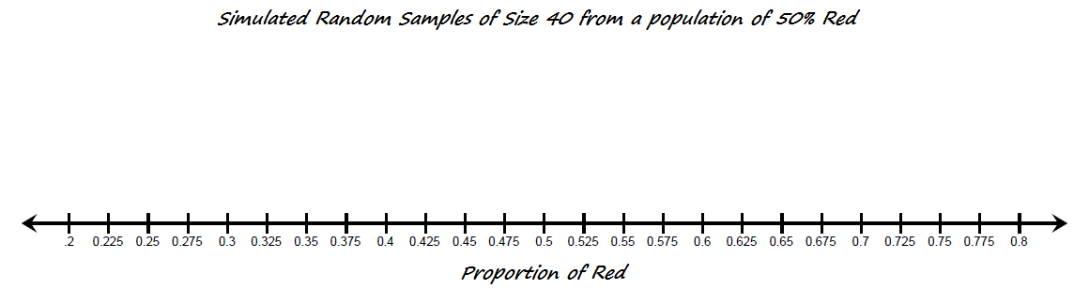

**Analysis**

* Describe the shape, center, and spread of the distribution of *Proportion of Red*.

__________________________________________________________

__________________________________________________________

__________________________________________________________

__________________________________________________________

* Approximately what proportion is at the center of the class dot plot? ________
* Are you surprised that this proportion is at the center? Why or why not?

___________________________________________________________

___________________________________________________________

* How many of the class samples were at 45% (18/40) or below? ________
* How many total samples were taken by your class? __________
* What proportion of your class samples are at 45% or below? __________
* If the actual proportion of students at Lincoln Middle School who buy their lunch at school is at least .5 (50% of the students), is it unusual to get a random sample of at most 45% of students who buy lunch at school?

___________________________________________________________

___________________________________________________________

___________________________________________________________

* Based on the simulation, which statement below offers the best conclusion?

_____ A. Marie’s sample proportion provides evidence that the principal’s claim was incorrect.

_____ B. Marie’s sample proportion does not provide evidence that the principal’s claim was incorrect.

* Suppose, instead, that when Marie took her random sample, she found that 12 of the 40 students bought a school lunch. Would this sample proportion cause you to doubt the principal’s claim? Explain.

____________________________________________________________

____________________________________________________________

____________________________________________________________

School Election

Marie’s friend, Jamal, is running for student council president. Fred, Jamal’s only opponent, claims that he will get at least 60% of the votes. Marie wants to show Jamal that his opponent’s claim is wrong. She takes a simple random sample of 30 students and finds that 11 of the students say they plan to vote for Jamal’s opponent.

* What proportion of the students in Marie’s sample plan to vote for Fred? _______

Next, Marie wants to conduct a simulation using red and white chips. She decides to let the red chips represent the students who plan to vote for Fred.

* Describe a sampling plan using red and white chips that Marie can use to simulate student voting.

_____________________________________________________________________________

_____________________________________________________________________________

_____________________________________________________________________________

_____________________________________________________________________________

_____________________________________________________________________________

Marie decides to take 50 random samples of chips for her simulation. Below is a graph of all the proportions from the 50 simulated samples.



* Based on the graph above and Marie’s actual random sample of 11 out of 30 students, is there evidence to conclude that Fred’s claim that he will get at least 60% of the votes is incorrect? Explain.

__________________________________________________________________________

__________________________________________________________________________

__________________________________________________________________________

|  |  |  |
| --- | --- | --- |
| **The Actual Population and Sample** | | **The Simulation** |
|  | Claim: **_______________________________________**  **__________________________________________________**  **__________________________________________________** | What do the red chips represent?  _____________________________________________________  What do the white chips represent?  _____________________________________________________ |
| The Population  What is the population? _____________________________  ___________________________________________________________  **___________________________________________________** | | The Population    What is the population in the simulation?  _____________________________________________________  _____________________________________________________ |
| The Sample    What is the sample?__________________________________  ___________________________________________________________  ___________________________________________________________  What is the size of the sample? _____________  What is the sample statistic and what is its value? ________________________________________ | | The Sample    What is the simulated sample?_______________  _____________________________________________________  _____________________________________________________  What is the size of this sample? _____________  What is this sample statistic and what is its value? ___________________________________________ |

**Teacher Notes**

New Illinois Learning Standards addressed by this activity:

Content Standards

|  |  |  |
| --- | --- | --- |
| ◎  Supporting | 7.SP.A.2 | Use data from a random sample to draw inferences about a population with an unknown characteristic of interest. Generate multiple samples (or simulated samples) of the same size to gauge the variation in estimates or predictions. *For example, estimate the mean word length in a book by randomly sampling words from the book; predict the winner of a school election based on randomly sampled survey data. Gauge how far off the estimate or prediction might be*. |

Primary Math Practices

MP 1 Make sense of problems and persevere in solving them.

MP 2 Reason abstractly and quantitatively.

MP 4 Model with mathematics.

MP 5 Use appropriate tools strategically.

**Guidance for School Lunch Activity**

There are several key ideas that should be emphasized in this activity.

* The proportion selected for the simulation is always based on the claim that is made. This claim may be about the percentage of students who will vote for a certain candidate for class president, the percentage of students who walk to school, the percentage of students who prefer an end of year trip to Great America over a school carnival, or, in this example, the percentage of students who buy a school lunch.
* To test this claim, a random sample is taken from the population. Students should know that the sample proportion from a simple random sample provides a good estimate of the population proportion. If the proportion in this random sample is close to the claimed value, we do not have enough evidence to reject the claim. However, if the sample proportion is relatively far from the claimed population proportion, then we conclude our sample provides evidence that the claim is not accurate. The question is, how far away does our sample proportion have to be from the population proportion in order for us to conclude that the claim is wrong?
* We carry out a simulation using a collection of chips, a coin, or a dice in which the simulated population characteristic is equal to the claimed value. In School Lunch, the principal claims that at least 50% of students buy school lunches. A paper bag population of chips is created in which 50% of the chips are red and 50% are white. This creates a simulated population with the same proportion as the principal’s claim. We then draw a simple random sample from the bag, using the same sample size as was used for the actual random sample of the population. In this activity, only 10 chips, 5 red and 5 white, are placed in the bag, and students are asked to draw one chip at a time, note its color, and return it to the bag. Sampling with replacement, allows us to use a small number of chips for the “population” while continuing to maintain the population proportion at .5. Another approach would be to create a large simulated population. For example, 400 red chips and 400 white chips can be placed in a large container, and, after thoroughly mixing the chips, a random sample of size 40 can be selected. Each student in the class can take a turn at selecting their random sample from this large population bag. Be sure to always mix between sampling.
* Provide opportunities for students to design the simulation. For example, a coin will be tossed 40 times to create samples of size 40 from a population where the claim is 50%, or placing 6 red chips and 4 blue chips in a bag to simulate a population whose characteristic of interest is 60%.
* In high school, students learn that a larger sample size creates a narrower sampling distribution. In other words, if we took a sample of size 50 in the School Lunch activity, we would expect there to be less variability amongst the simulated samples and less spread in the sampling distribution. This concept is beyond the scope of the seventh grade standards. However, it is important that students know that they must use the same sample size in their simulation as was used in the random sample of the actual population. In seventh grade, students should observe that as more and more samples are selected, the distribution of all these sample proportions will be approximately symmetrical and the center of the distribution will get closer and closer to the actual population proportion. In School Lunch, if each student in your class took another 4 samples, the distribution of the sampling proportion would become more symmetrical, and the center of the distribution would get closer and closer to .5.
* Once a sampling distribution has been created, we compare the actual sample proportion taken from the population of students, in this case 18/40 or .45, to the simulated sample proportions. In the table that follows are three different sampling distributions created based on taking 24 random samples from a paper bag that contained 50% red chips. (This is based on a class of 24 students each taking a random sample from their population bag and sharing the results.) Do we see values of .45 or lower? Note that for distributions A, B, and C in the table below, getting a sample that was 45% red or less from a population of 50% red has a probability of .33, .29 and .25 respectively. This indicates that a sample of at most 45% red when the population is 50% red is not unusual. Returning to our lunch example, the sample of 18/40 collected by Marie does not provide sufficient evidence that the principal’s claim is incorrect.
* Suppose instead that Marie’s sample had 12 out of 40 (30%) students who bought a school lunch. None of our sample proportions from graphs A, B and C had a value this low. It would be unlikely for us to be able to randomly select a sample with 30% buying school lunches if the population is 60%. Our proportion of 12/40 from our random sample makes us doubt that the population of students who buy school lunches is really 60%. We say that the sample provides evidence that the principal’s claim is incorrect.
* Finally, consider the conclusion we might draw if the proportion from the random sample of the student population was 14 out of 40 (35%). Graph A shows that two samples from the simulation had a proportion of .35 or lower. Would 2 samples out of 24 samples, approximately 8%, make us doubt that the population proportion was actually .6 (60%)? The simulated value of 8% indicates that the probability of getting a sample of .35 or lower from a population that has a proportion of .6 is .08. This is a low probability, but not entirely unlikely. Students may argue either way on this as long as they support their reasoning with a sound statistical argument.

|  |  |  |
| --- | --- | --- |
| **Example class sampling distributions:**  **Class of 24 students (24 samples)** | **Number of samples with at most 45% Red** | **Percentage of samples with at most 45% Red** |
| A. | 8 | $$\frac{8}{24}= .33$$ 33% |
| B. | 7 | $$\frac{7}{24}= .29$$ 29% |
| C. | 6 | $$\frac{6}{24}= .25$$ 25% |

**Acknowledgements**

Beth Chance and Allan Rossman have given permission for the Reeses Pieces applet to be shared with Illinois math teachers. The applet is available at <http://www.rossmanchance.com/applets/OneProp/OneProp.htm?candy=1>.

The Reeses Pieces applet available at [www.rossmanchance.com](http://www.rossmanchance.com) can be used to simulate the long run behavior of random sampling. While we used red chips in our hands-on simulation, the applet uses orange Reeses Pieces. The settings shown below can be used to simulate taking a sample of size 40 from a population with a population proportion of .5. You may first want to take the same number of samples as taken by your class. In the example below, I took 24 random samples. However, you can continue to draw more and more samples to show students what happens when 100 or even 500 random samples are taken. The applet can be used to count the number of samples with a proportion that is at most .45 (18/40).

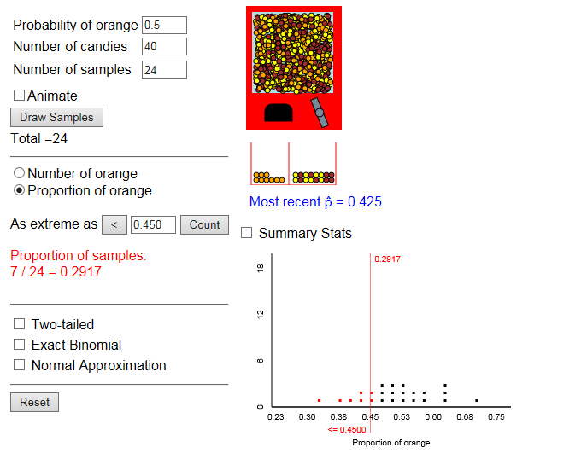

**Answer Key**

School Lunch

* *The population is all Lincoln Middle School students.*
* *The population characteristic that we are interested in is the proportion (percentage) of the Lincoln Middle School students that purchase a school lunch.*
* *The sample is the 40 randomly selected Lincoln Middle School students.*

$\frac{18}{40}= .45$

The Simulation

* *The proportion of red chips is 0.5.*

Analysis

* (Answers will vary.)

Sample response: *The distribution of the proportion of red chips in samples of size 40 is approximately symmetrical. The lowest sample proportion of red chips was 0.325 $\left(\frac{13}{40}\right)$ and the highest proportion was 0.7 $\left(\frac{28}{40}\right)$ for a range of 0.325. The distribution is centered at a proportion of about 0.5(50%) red chips in a sample.*

* *0.50*
* (Answers will vary.)

Sample response: *No, I am not surprised. The center of the dot plot of all the sample proportions is approximately equal to 0.50 (50%) red chips in a sample. I expected the distribution of all the sample proportions to be centered at approximately the value of the population proportion of red chips in the paper bag populations.*

.

.

.

* *B is the statement that offers the best conclusion.*

$\frac{12}{40}=0.30$

(Answers will vary.)

*Sample response: None of the samples in our dot plot had a sample proportion this small. It is unlikely that the actual proportion of students at Lincoln Middle School that buy a school lunch is 0.5 if a random sample of the population has a proportion of 0.3. The sample proportion provides evidence that the proportion of Lincoln Middle School students that buy a school lunch is likely to be less than 0.5.*

School Election

* (Answers will vary.)

A student response should:

* Describe what the red and white chips represent in the context of the situation.
* Indicate 60% of the chips is the color representing students who plan to vote for Jamal’s opponent. (Always use the claimed value for the proportion of chips in the simulation.)
* Describe a method of sampling randomly.
* Indicate that a sample of size 30 will be selected. (The same sample size as Marie’s random sample.)

*Let red chips represent the students who plan on voting for Fred and white chips represent the students who are not planning on voting for Fred. Place 6 red chips representing the students who plan on voting for Fred and 4 white chips in a paper bag so that the proportion of red chips is equal to the claimed value of 0.60. Shake the bag to mix the chips. Select one chip at a time, record the color, and replace the chip back in the paper bag. Repeat until a sample of 30 chips has been selected.*

* (Answers will vary.)

Sample response:

*Yes, there is evidence that Fred’s claim is incorrect. Marie’s sample proportion is $\frac{11}{30} ≈0.37$. None of the simulated sample proportion had a value as low as 0.37. It is unlikely that the proportion of students who plan on voting for Jamal’s opponent is 0.60 (or higher) if a random sample of the population has a sample proportion of 0.37. The actual proportion of students who plan on voting for Fred is likely to be less than 0.60.*