Algebra II / Math II Conditional Probability Standards

- All 498 students from an elementary school were asked whether they preferred reading fiction or non-fiction. Of the 262 girls, 202 prefer fiction. 164 of the 236 boys prefer non-fiction.

Complete the table. Include counts in the chart, tree and Venn Diagram.
If a student from this school is selected at random find the probability that:  P(Male) = ____________ P(Female) = _____________  P(Fiction) = ___________ P(Non-Fiction) = _________  P(Non-Fiction | Male) = ___________  P(Non-Fiction | Female) = __________  Do the same proportion of males and females prefer non-fiction? ______  Does P(Non-Fiction | Male) = P(Non-Fiction | Female) = P(Non-Fiction)?  Based on the data, are boys at this elementary school more likely to prefer non-fiction, or is the preference of non-fiction independent of gender? | 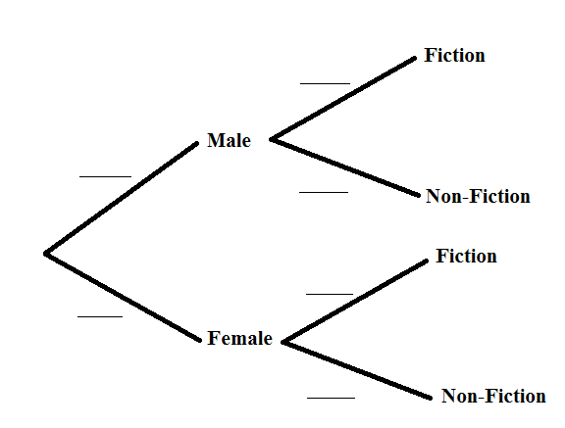
Fiction Non-Fiction Total  Male  Female  Total | 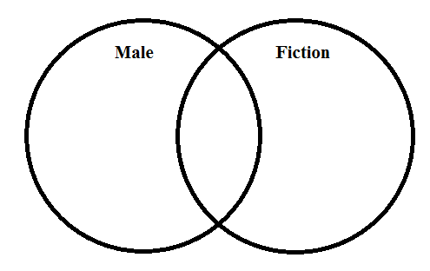
- Are high school seniors more likely to own a smartphone than other high school students? Or is owning a smartphone independent of high school grade? A sample of 240 high school students was asked if they owned a smartphone. Their responses are recorded in the chart below.

Complete the table. Include counts in the tree, provide the indicated probabilities, and answer the questions below.
Do you own a smartphone?  Yes No Total  9th Grade 195 109 304  10th Grade 183 103 286  11th Grade 173 97 270  12th Grade 154 86 240  Total 705 395 1100 | 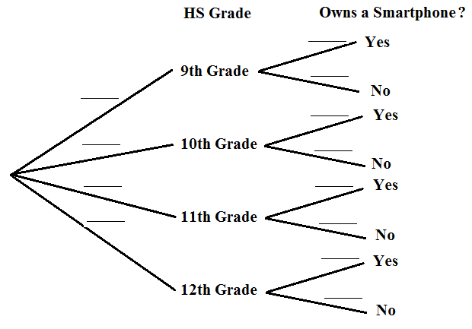
If a student from this sample is selected at random find the probability that:  P(Smartphone) = ________  P(Smartphone | 9th) = ________ P(Smartphone | 10th) = _______  P(Smartphone | 11th) = _______ P(Smartphone | 12th) = _______  Based on your work above, is owning a smartphone independent of high school grade? Support your answer using probability reasoning. | Multiply down the branches to find the following probability:  $$P\left(12th ∩Smartphone\right)=____________$$  Does $\left(12th ∩Smart Phone\right)=P\left(12th\right)∙P(Smartphone)$ ?  Show work to support your answer.  If $P\left(12th ∩Smartphone\right)=P\left(12th\right)∙P(Smartphone)$, what can you conclude?

3.  A sample of 480 adults was asked if they smoke and if they like country music. Complete the tree, chart and Venn Diagram with possible counts if smoking is independent of liking country music. | 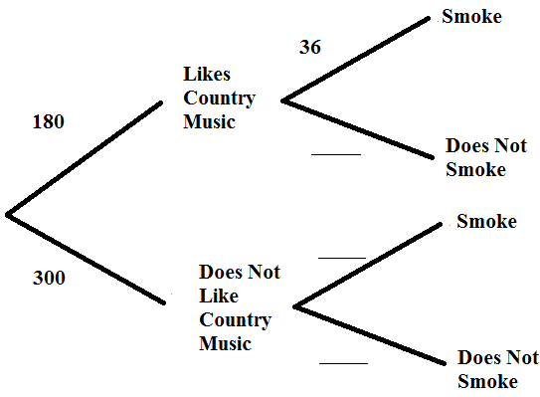
Smokes Does Not Smoke Total  Likes  Country Music  Does Not Like  Country Music  Total | 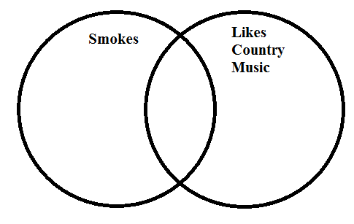

Teacher Notes:
This activity is adapted from an activity featured in the Math II Curriculum on the Math Vision Project website.

In 7th grade, students learn to represent sample spaces using organized lists, trees and tables. In 8th grade and Algebra I / Math I, students work with bivariate categorical data to find relative and marginal frequencies. Algebra II/ Math II students build on prior learning in their work on the Conditional Probability standards. While Venn Diagrams have been used as an organizational tool in the problems above, Venn Diagrams are not explicitly mentioned in the Common Core Standards.

Given events A and B.

Standard S.CP.3 focuses on the conditional probability rule: $P\left(A \right|B)= \frac{P(A∩B}{P(B)}$

If both sides of this equation are multiplied by P(B), $P\left(B\right) ∙ P\left(A \right|B)= \frac{P(A∩B}{P\left(B\right)} ∙ P(B)$

the result is: $P\left(B\right) ∙ P\left(A \right|B)= P(A∩B)$’

OR

$P(A∩B)= P\left(B\right) ∙ P\left(A \right|B)$

This is the general multiplication rule mentioned in Standard S.CP.8 (+),

If events A and B are independent, then Standard S.CP.3 reminds us that P(A) = P(A | B) .

Substituting P(A) in for P(A|B) in the general multiplication rule, we get the multiplication rule for two independent events.

$P(A∩B)= P\left(B\right) ∙ P(A)$

OR

$P(A∩B)= P\left(A\right) ∙ P(B)$

This is the rule mentioned in S.CP.2. It provides another method for testing to see if two events are independent. If P(A) times the P(B) equals $P(A∩B)$, then events A and B are independent.

