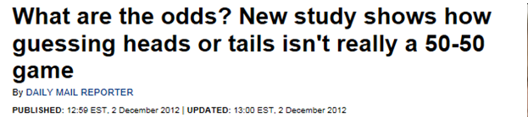
http://www.dailymail.co.uk/news/article-2241854/What-odds-New-study-shows-guessing-heads-tails-isnt-really-50-50-game.html

