Sleep Deprivation

This activity is based on an activity from Investigating Statistical Concepts, Application and Methods by Beth Chance and Allan Rossman.

Researchers have established that sleep deprivation has a harmful effect on visual learning. In a recent study, Stickgold, James, and Hobson (2000) investigated whether subjects could “make up” for sleep deprivation by getting a full night’s sleep in subsequent nights. This study involved randomly assigning 21 subjects (volunteers between the ages of 18 and 25) to one of two groups: One group was deprived of sleep on the night following training with a visual discrimination task, and the other group was permitted unrestricted sleep on that first night. Both groups were allowed unrestricted sleep on the following two nights and then were retested on the third day. Subjects’ performance on the test was recorded as the minimum time (in milliseconds) between stimuli appearing on a computer screen for which they could accurately report what they had seen on the screen. Previous studies had shown that subjects deprived of sleep performed significantly worse the following day, but it was not clear how long these negative effects would last. The data are presented here (a negative value indicates a decrease in performance): (Chance & Rossman, p.2-43)

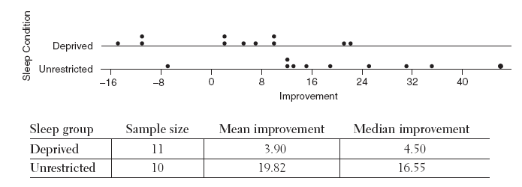

What is the difference between the means for the two groups? ____________

If the sleep deprivation group and the unrestricted sleep group had the same improvement, what would you expect the difference of the two group means to be? ______

Based on the graph and statistics below, do you think there is evidence that sleep deprivation on the first night might have had an effect on a subject’s improvement on the visual discrimination task? Explain.

- Formulate Question(s)

- Does the effect of sleep deprivation linger or can we “make up” for lost sleep?

- Primary question of inference:
If the treatment had no effect, is it possible that we would see this great a difference simply by chance (random assignment)?
- Design and Implement a Plan to Collect the Data

To determine if it is possible that we would see this great a difference simply by chance, we will conduct a simulation. Imagine if we could randomly assign these 21 subjects to one of the two treatment groups over and over again. Would we see a difference as great or greater between the means of the two groups? If the difference between the two groups is frequently as great or greater, than the observed difference between the means, could simply happen by chance. However, if we find that we rarely get a difference as great as 15.92 (or greater) between the two means, then the observed difference of 15.92 must be due to the difference in the two treatments.

Here is the data for the 21 subjects:
(A negative value indicates a decrease in performance.)

Sleep Deprivation Group | -10.7 | 4.5 | 2.2 | 21.3 | -14.7 | -10.7
 | 9.6 | 2.4 | 21.8 | 7.2 | 10.0
Unrestricted Sleep Group | 25.2 | 14.5 | -7.0 | 12.6 | 34.5
 | 45.6 | 11.6 | 18.6 | 12.1 | 30.5

Write each of the improvement scores on a separate card. Shuffle the cards and deal them into two groups. The first group will be sleep deprivation. The second is unrestricted sleep. Find the mean of each group, then find the difference in the two means. Plot this value on the class dot plot and record the value on the class table. Repeat the process 4 more times.

Trial | Sleep Deprivation  Group Mean | Unrestricted Sleep Group Mean | Difference in Group Means
1
2
3
4
5

III. Analyzing the Data

Copy the class dot plot in the space provided below.

Mean Difference in Improvement Score for Each Simulated Trial

Together with your classmates, determine the mean and standard deviation of the differences in improvement scores for all the simulated trials.

Mean of all trials: ________________

Standard deviation for all trials: _______________

VI. Interpret the Results

How many of the class samples had a difference in the means of 15.92 or higher? _______

What percent of all the class trials is this? ________

How likely is it to get a difference in the mean improvement score that is 15.92 or higher by chance (random assignment)?

Can we conclude cause and effect? Please explain why or why not.

Can we generalize our findings for the sample to a population? (What is the population of interest in this study?)

Teacher Notes
New Illinois Learning Standards addressed by this activity:
Content Standards
Major | S | IC.5 | Use data from a randomized experiment to compare two treatments; use simulations to decide if differences between parameters are significant.
Major | S | IC.6 | Make inferences and justify conclusions from sample surveys, experiments, and observational studies. Evaluate reports based on data.*
Primary Math Practices
MP 2 Reason abstractly and quantitatively.
MP 4 Model with mathematics.
MP 5 Use appropriate tools strategically.
MP 6 Attend to Precision.
MP 7 Look for and make use of structure.

Acknowledgements
This activity is adapted from an activity shared by Beth Chance and Allan Rossman. An applet that simulates the long run probabilities for this activity, shared with permission from Beth Chance and Allan Rossman, is available http://www.rossmanchance.com/applets/randomization20/Randomization.html. The applet is titled Randomization Test for Quantitative Response (two groups).

Guidance for this Activity
Below is an example graph of 1000 trails using the applet mentioned above.

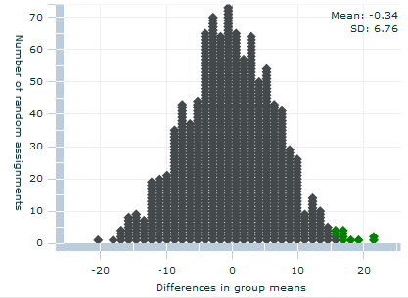
10 out of 1000 samples (1.0%) were 15.92 or higher.
Not very likely!
Notice the sampling distribution is approximately normal and centered close to 0. When the improvement scores are randomly assigned to the two treatment groups, the average difference between the means of the two treatment groups is close to 0. The standard deviation for the sampling distribution is 6.76. Anything out beyond two standard deviations would be considered an unusually large value (outlier). Two standard deviations above the mean would be 2(6.76) = 13.2. In the experiment, the difference between the means of the two treatment groups was 15.92. This is more than two standard deviations above the mean. It is not very likely that we would get a difference of means as high as 15.92 just by random sampling.

