Kamataka
(Adapted from PARCC Item Development ITN 2013-31 Appendix F)

Kamataka is a state in southwest India. The accompanying table is agricultural data on fertilizer use and grain crop yield in Kamataka. Fertilizer is measured in 100,000 tons. Crop yield is measured in 10 kilograms per hectare.

Throughout the years over which these data were gathered, the amount of land in cultivation remained fairly constant.

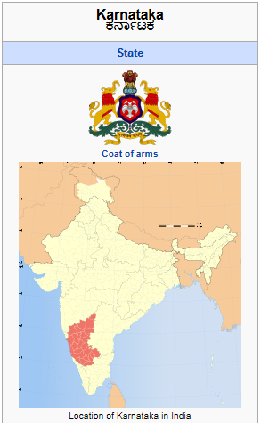 | Year Fertilizer (X 10⁵ tons) Yield (X 10 kg/ha)  1956 0.06 52.3  1966 0.38 45.8  1970 1.32 19.1  1974 1.95 88.9  1975 2.32 82.9  1976 2.03 93.9  1977 2.08 79.2  1978 2.9 97.9  1979 3.72 101.7  1980 3.59 102.9  1981 3.54 91.9  1982 3.87 102.2  1983 3.83 85.8  1984 4.87 102.1  1985 5.9 95.4  1986 5.55 81.19  1987 5.66 97.03  1988 5.58 83.57  1989 5.75 93.5

- Write a mathematical function that models the relationship between fertilizer use and grain crop yield. Show your work.

- Use the function you have chosen to predict the yield if the fertilizer use is 500,000 tons.

- How precise is the prediction you made in Questions (b)? Explain.

- Based on the data and your function, what advice can you offer the government of Kamataka about fertilizer use? Explain.

